Lab 00: Environment Preparation

Demo Tenant and Trial Licenses

To deploy Microsoft Vaccination Management in a Dataverse environment, both a tenant and required pre-requisite licenses needs to be added.

In this exercise, you will be playing the role of a System Administrator and learn to create a demo tenant along with the required trial licenses. You can skip this exercise if you have already created a demo tenant and added the trial licenses.

Task 1: Create a Demo Tenant

In this task, you will learn to create a demo tenant along with the required Dynamics 365 and Power apps trial licenses. You can skip this task if you already have a tenant.

1. Open an internet browser in either In-Private or Incognito mode.
2. Navigate to <https://trials.dynamics.com> and click on **Sign up here**.

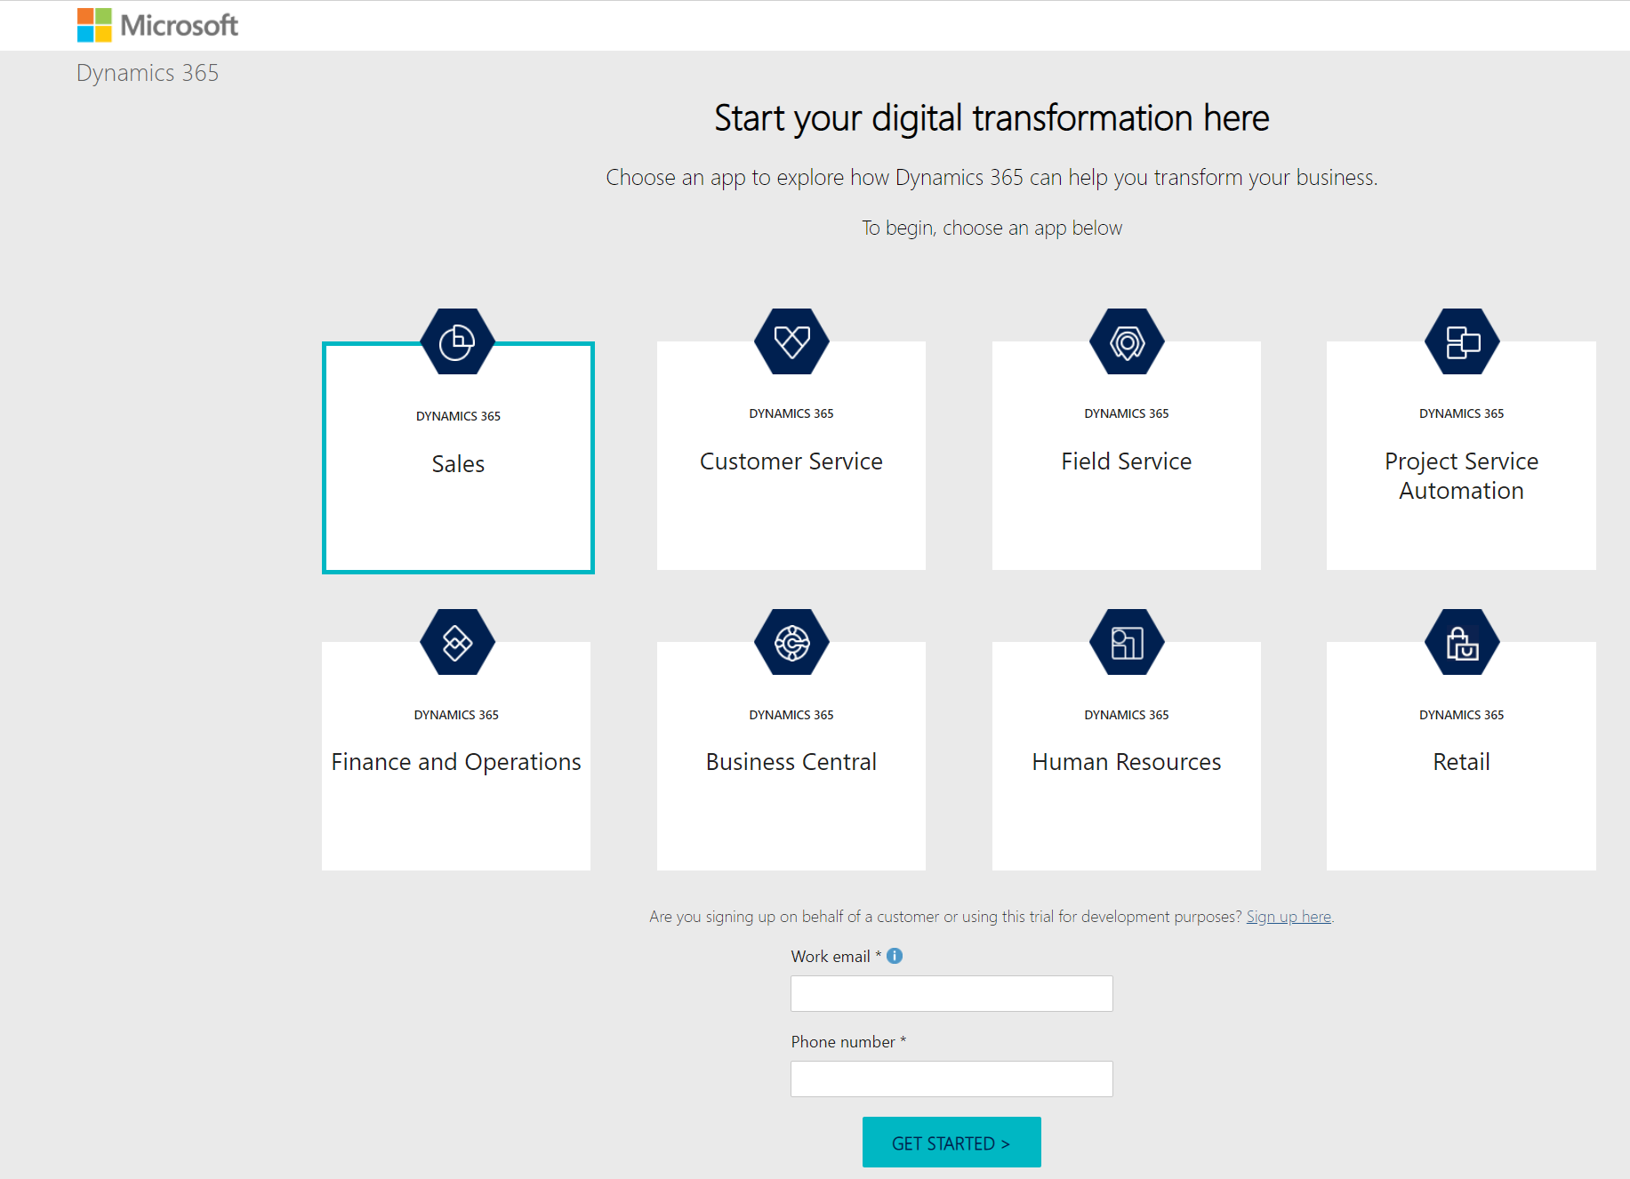

1. You will get a pop-up asking you if you are a partner or Microsoft employee. In this case we’re going to click “no and continue signing up”

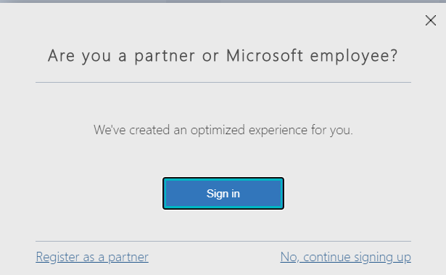

1. Enter your email address and click “Next”.

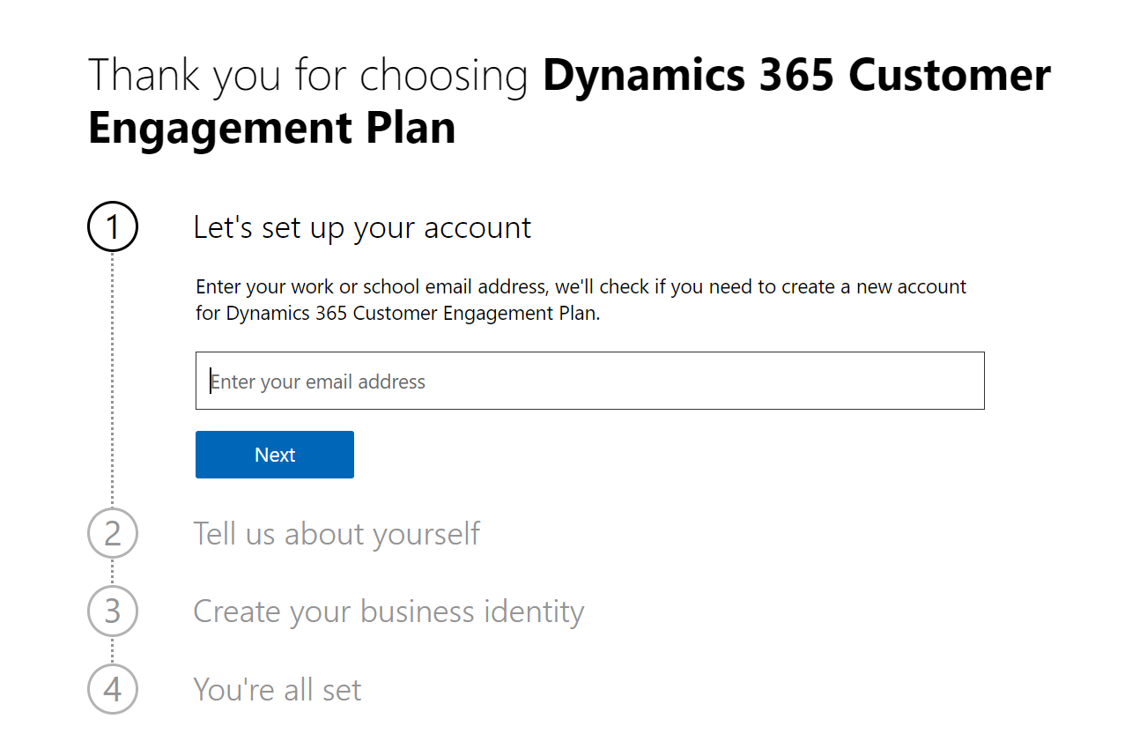

1. Click on “Set up account”.

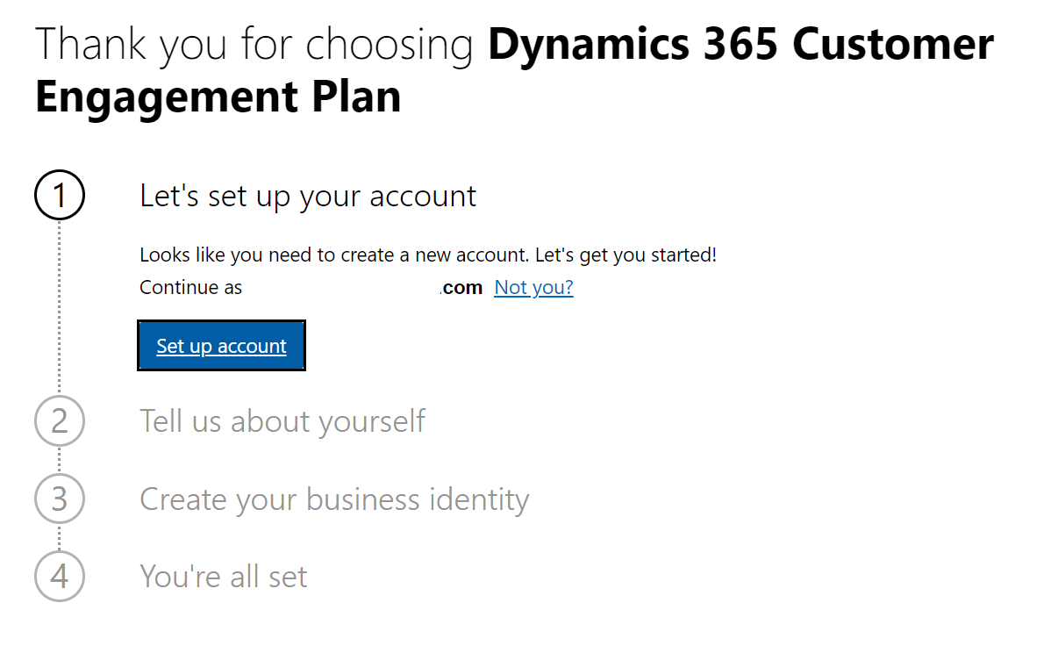

1. Provide the necessary information required. Provide a phone number where you can either be texted or called with a verification code to prove that you are not a robot.

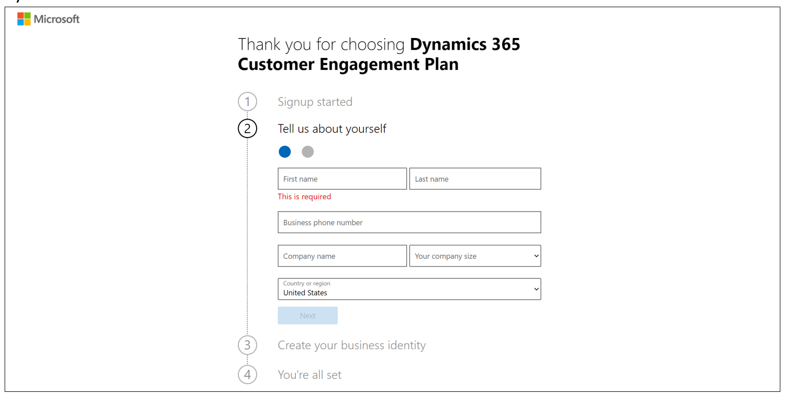

1. Once the code is verified, create your new domain, which will be the unique name used to identify your Dynamics 365 tenant. Finish creating your business identity user and sign up

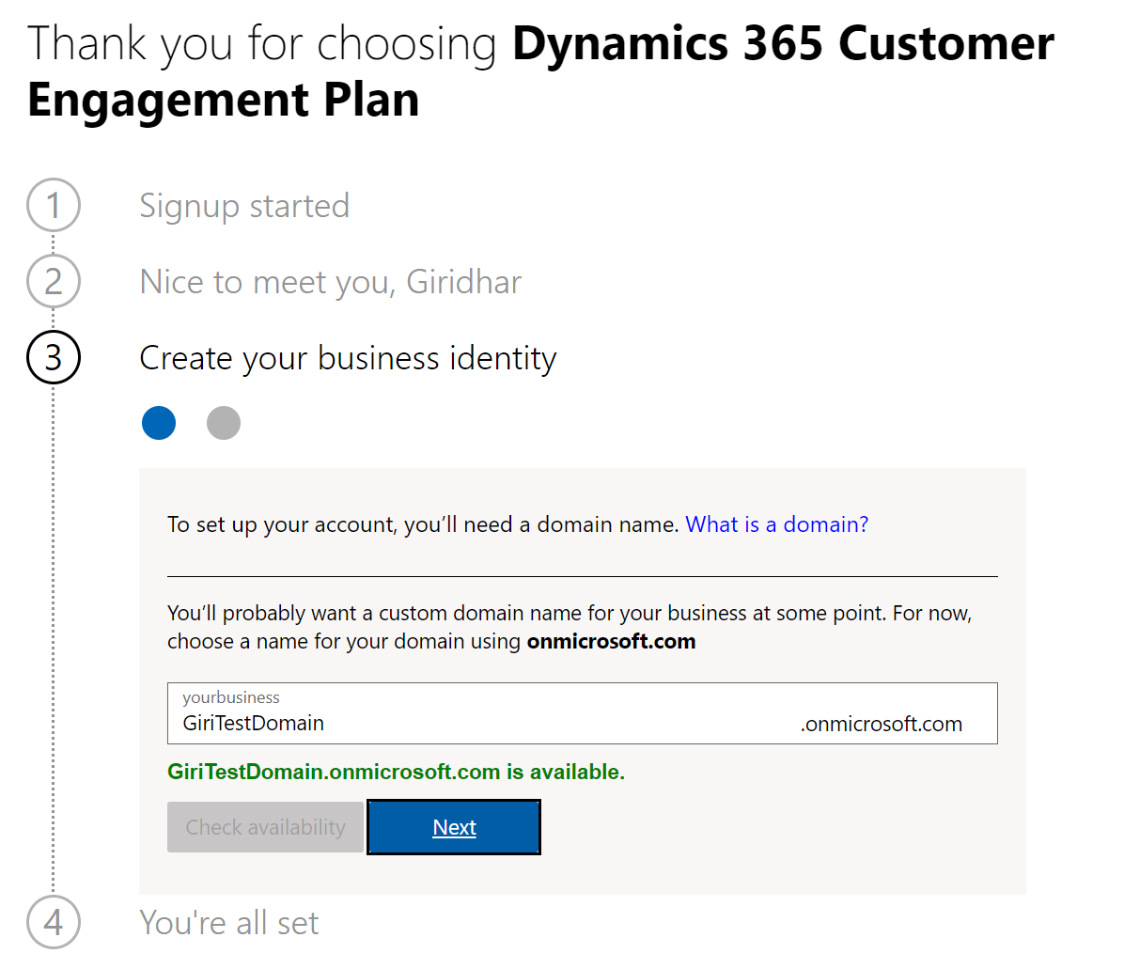

1. Setup a User ID and password in your new domain and click on Sign up.

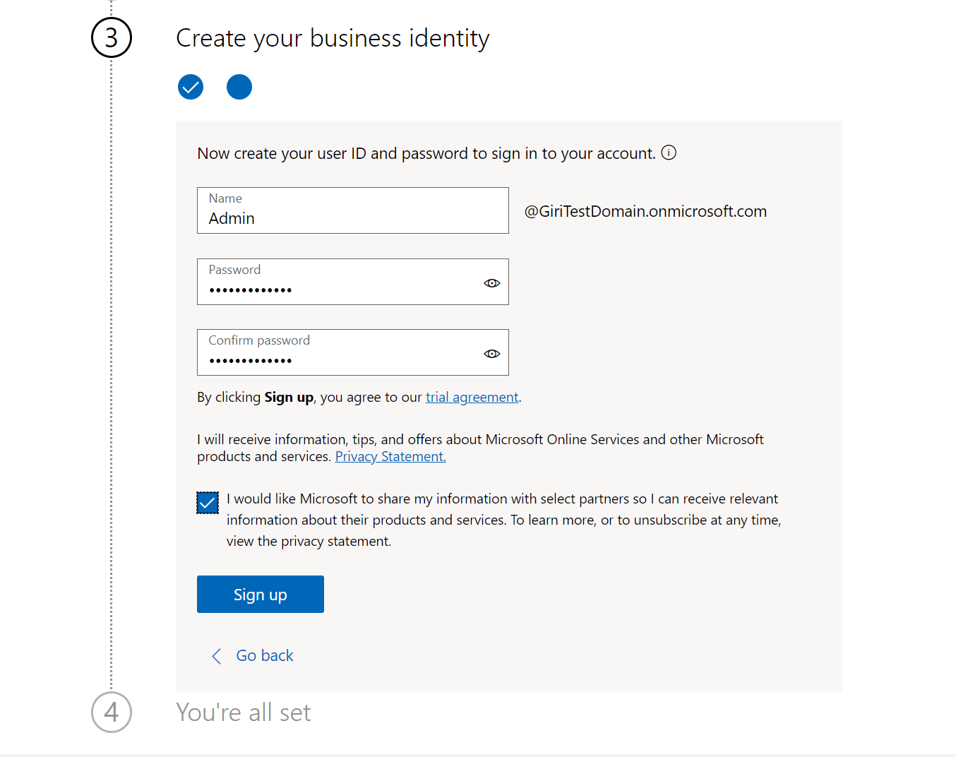

**Congratulations**! Your Microsoft 365 tenant has been successfully created along with Dynamics 365 Customer Engagement Plan license which includes Power Apps license as well.

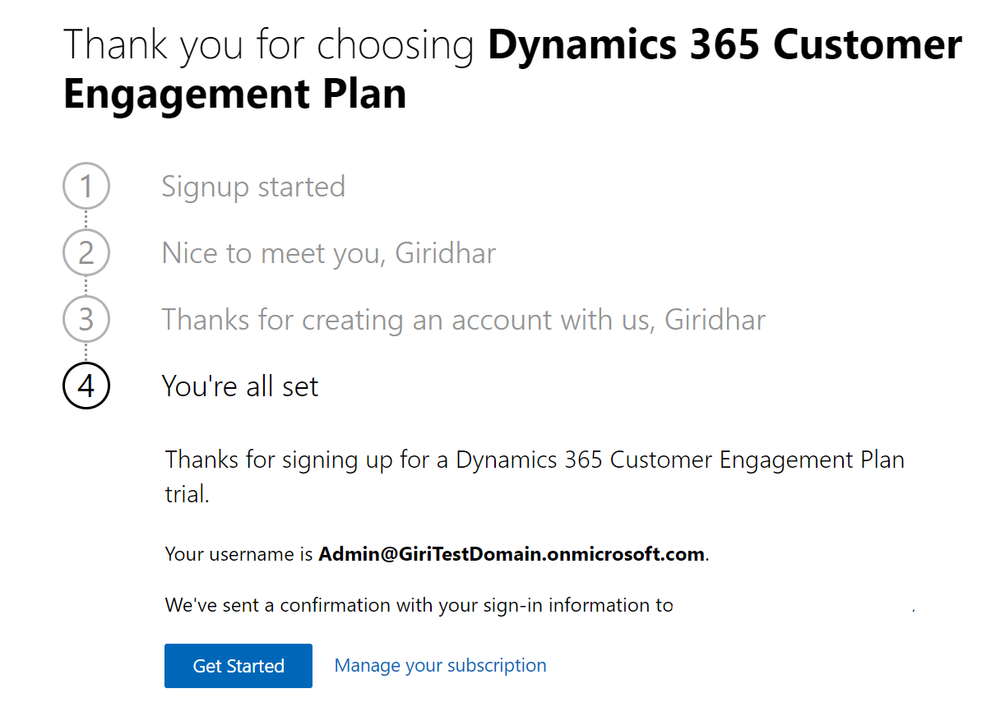

Task 2: Add pre-requisite licenses

In this task, you will learn to add the other pre-requisite trial licenses (Office 365 E5 for sending/receiving emails and Power BI Pro to deploy and view the MVM Dashboards) which are required for you to complete the labs.

1. Navigate to <https://admin.microsoft.com> and sign-in with the credentials created in Task 1.
2. Select “Purchase Services” on the left pane and search for “Office 365 E5” in Office 365 Category. Click on “Details” on Office 365 E5.

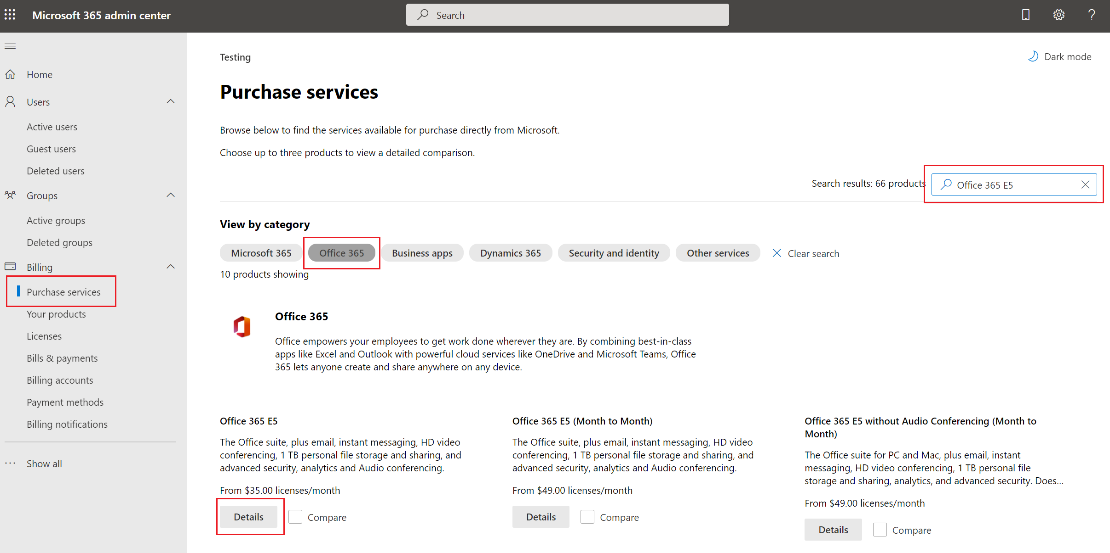

1. Click on “Start free trial”.

1. Provide the same phone number used while creating the tenant.

1. Provide the code and click on “Start your free trial”

1. Click on “Try now” and then “Continue” to checkout the free trial order.

1. Navigate to Admin Center Page, select “Purchase Services” on the left pane and search for “Power BI Pro” in “Power BI” Category. Click on “Details” on “Power BI Pro”

1. Click on “Start free trial”

1. Click on “Try now” and then “Continue” to checkout the free trial order.

**Congratulations!** You have now added Office 365 E5 and Power BI Pro Trial Licenses. Assign the new licenses to the required users in the tenant.